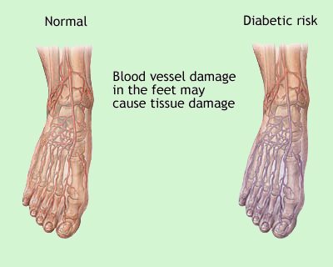
Diabetic neuropathy is a type of nerve damage, which makes it hard for nerves to carry messages to the brain and other parts of the body.
Diabetes: Foot Care

What are the symptoms of diabetic neuropathy?
- Numbness (loss of feeling) or painful tingling and burning in parts of the body, especially your fingers, toes, hands or feet
- Muscle weakness and difficulty walking
- Cuts, sores or blisters on your feet that don't hurt as much as you would expect, and that also heal very slowly
- Bladder problems such as urinary tract infections and loss of bladder control
- Bloating, abdominal pain, constipation, nausea, vomiting and diarrhea.
- Erectile dysfunction (in men) and vaginal dryness (in women)

What causes diabetic neuropathy?
Diabetes causes the level of sugar in your blood to be higher than normal. Over time, high blood sugar levels damage the blood vessels and nerves. That's why people who don't control (or can't control) their blood sugar very well seem more likely to get diabetic neuropathy. Men are more likely to have diabetic neuropathy than women. High cholesterol levels and smoking also increase your risk.

How is diabetic neuropathy treated?

Treatment focuses on slowing the development of the condition through controlling blood sugar levels and making lifestyle changes. They include: a healthy diet, exercise regularly, maintaining a healthy weight, controlling blood pressure, quit smoking, and limit alcohol use. Treatment for diabetic neuropathy also focuses on relieving pain and discomfort. There are several medicines available that help ease neuropathy pain.

What can I do to avoid diabetic neuropathy?
The most important thing is to keep your blood sugar under control. Take your medicines and/or insulin exactly as your doctor prescribes. Eat a healthy diet. If you are overweight, ask your doctor to help you lose weight. Get plenty of exercise.
- Wash your feet every day with lukewarm (not hot) water and mild soap.
- Dry your feet well, especially between the toes. Use a soft towel and pat gently; don't rub.
- Keep the skin of your feet smooth by applying a cream or lanolin lotion, especially on the heels. If the skin is cracked, talk to your doctor about how to treat it.
- Keep your feet dry by dusting them with non-medicated powder before putting on shoes, socks or stockings.
- Check your feet every day. You may need a mirror to look at the bottoms of your feet. Call your doctor if you have redness, swelling, pain that doesn't go away, numbness or tingling in any part of your foot.
- Don't treat calluses, corns or bunions without talking to your doctor first.
- Cut toenails straight across to avoid ingrown toenails. It might help to soak your toenails in warm water to soften them before you cut them. File the edges of your toenails carefully.
- Don't let your feet get too hot or too cold. Don't go barefoot.

