Treatment Options

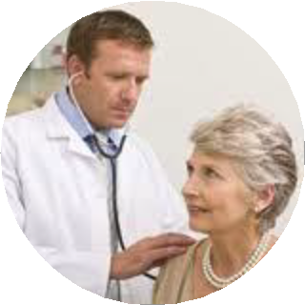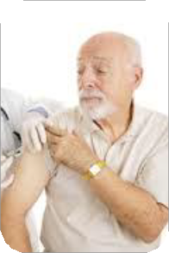COPD is not curable but there are treatments that can help you feel better

➢ Bronchodilators help relax and open your airways

➢ Corticosteroids reduce irritation and swelling of your airways

➢ Oxygen Therapy increases the level of oxygen you breath

➢ Expectorants help loosen the mucus in your airways helping you to cough up the extra mucus

➢ Vaccinations help keep you healthy by preventing infections

o FLU

o PNEUMONIA

Exacerbations

COPD exacerbations are attacks called flare-ups

Symptoms of flare-ups include:

• coughing up more mucus

• change in mucus

• shortness of breath

• increased anxiety

• difficulty sleeping

• changes in skin color

The most common cause of flare- ups is infection (viral or bacterial)

Flare-ups can be harmful and you need to be treated

Discuss a plan with your provider

Living with
COPD

What is COPD?

Chronic Obstructive Pulmonary Disease (COPD) is a lung disease that makes it hard to breathe. COPD is a mix of two diseases called emphysema and chronic bronchitis. Emphysema causes permanent damage in the lungs. It weakens and breaks the air sacks (alveolus) in the lungs. As the air sacks break it forms space. The air cannot get out of the spaces or out of the lungs. Chronic bronchitis causes scar tissue. It also thickens the lung tubes (bronchiole). The body produces mucus to sooth the tubes causing them to narrow more. Both of these diseases make it difficult to breath. There is no cure. Treatment can help you feel better and stay healthy.

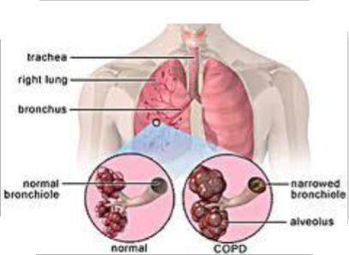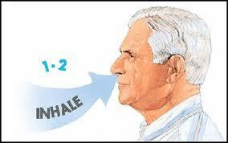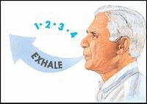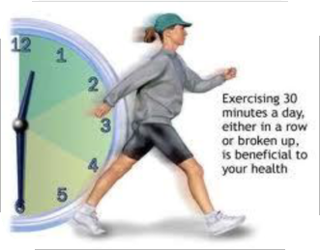

What causes COPD?

• The #1 cause is smoking

• Secondhand smoke from other
people’s cigarettes

• Heavy exposure to air pollution

• Working with chemicals and in very dusty areas over many years

• History of frequent upper respiratory infections

• Pneumonia during childhood

• Heredity – this is rare
What YOU Can Do To Stay Healthy

✓ Quit smoking

✓ Avoid secondhand smoke

✓ Do Breathing Exercises

✓ Manage Stress

✓ Exercise Strengthening

✓ Conserve Energy

✓ Eat Healthy Foods

✓ Take Medications

